**A Deep Learning-Based Hybrid Differential Bond Energy Algorithm for Improving Information Mining Document Clustering**

D.Udaya Suriya Rajkumar1

1* Professor, Department of Computer Science and Engineering , Global Institute of Engineering and Technology, Ranipet, Tamil Nadu, India. Email: u_suriya@yahoo.com

**Abstract**

**Background**: Document clustering is a critical task in information mining, aimed at grouping similar documents based on their content to improve data organization and retrieval. This study introduces a L-HDBEA to enhance the clustering process, offering a novel approach to document analysis through the fusion of deep learning and advanced clustering techniques.

**Problem**: Existing document clustering methods often struggle with scalability, accuracy, and the ability to handle complex, high-dimensional data. Traditional approaches face challenges in maintaining cluster cohesion and distinguishing between subtle similarities, which leads to poor performance, especially in large datasets.

**Method**: To address these issues, the proposed Deep Learning-Based Hybrid Differential Bond Energy Algorithm (DL-HDBEA) framework integrates the power of deep learning with a refined differential bond energy algorithm. The deep learning component aids in feature extraction using Convolutional Neural Networks (CNNs), enhancing the ability to discern intricate patterns in the document data. The hybrid approach then leverages the improved bond energy algorithm, which refines the clustering process and ensures better separation between clusters. This CNN-based deep learning method adapts dynamically to varying data characteristics, offering a robust solution to clustering challenges.

**Finding**: The proposed method is applied to real-world datasets in information mining tasks, demonstrating superior performance over conventional clustering algorithms. Experimental results reveal that L-HDBEA significantly improves clustering quality, scalability, and computational efficiency, outperforming existing techniques in both precision and recall metrics. These findings suggest that the proposed method can be effectively employed for large-scale document clustering tasks across various domains.

**Keywords**: Document clustering, **Deep Learning,** bond energy algorithm, information mining, CNN

1. **Introduction:**

Among the many very important criteria used in text mining is the similarity measure. The degree to which two text texts resemble one another can be ascertained with the help of the similarity metric [1]. It is the term-frequency way in which the traditional method of text description has been done, seeing the document as a vector that contains a set of words and the frequency [2]. There are two major problems in this method: synonymy and polysemy, two words are assumed to be synonyms if they can be replaced for each other in the same situation; synonyms are words which have the same semantic content [3]. Car, automobile, vehicle all can denote the same word in the same sentence. There exist a possibility to form synonymous words into clusters called thesauruses and its devices [4]. Text mining, a form of advanced data analysis, is becoming increasingly important because of the ever-increasing volume of text found on the internet and in intelligent applications [5]. Similar to other deep learning and pattern recognition applications, text document clustering is an essential method used in the text mining industry [6].

A process that sorts a collection of documents into hierarchies of related concepts [7]. Text document clustering is often used for tasks such as automatically extracting topics, organizing documents, and retrieving information [8]. Several applications are made easier by clustering, including picture recognition, search engines, text classification, and text categorization [9]. Several Meta-Heuristics optimization techniques have been suggested in recent years to address the optimization issue of text document clustering, which is considered NP hard [10]. Eight datasets were used to assess the performance of the suggested method, DL-HDBEA which was used for both text clustering [11]. Additionally, it enhanced dependability while decreasing the computing time cost [12].

Deep learning models that have been successful thus far have their roots in biology, namely in the ways in which organisms learn, adapt, and evolve in response to their environments [13]. Brain structure, consisting of dense local clusters of the same neurons, is the basis of neural networks and deep learning [14]. Dense clusters carry out distinct tasks and are linked to one another via sparse long-distance connections and an abundance of short-distance ones [15]. Clusters of neurons become more specialized as a result of their adaptations during learning activities, which allows the brain to process vast amounts of data collected from the senses, evaluate the information, and ultimately choose the relevant facts [16]. Although traits gained from living things are not inherited, the adaptations that have been learnt have an impact on and may direct evolution [17].

**Motivation:** The increasing need for efficient and scalable clustering approaches to manage massive datasets is driving this research. Accuracy, recall, and computing efficiency are three areas where traditional algorithms often fail. Our hope is that by creating DL-HDBEA, it can overcome these restrictions and make information mining in the real world more efficient, scalable, and effective across a wide range of fields.

**Problem Statement:** While dealing with complicated, high-dimensional data, scalability, and accuracy are common challenges for document clustering algorithms. Conventional algorithms perform poorly since they can't keep clusters together and can't distinguish between very similar things. increasingly sophisticated methods are required to improve the quality and efficiency of clustering in a variety of contexts, since these shortcomings become increasingly apparent in large-scale datasets.

**Contribution of this paper,**

* Introduces the Deep Learning-Based Hybrid Differential Bond Energy Algorithm (DL-HDBEA), combining deep learning for feature extraction and a refined bond energy algorithm for enhanced document clustering performance.
* Utilizes Convolutional Neural Networks (CNNs) for advanced feature extraction, significantly improving the model's ability to discern intricate patterns and subtle similarities in complex, high-dimensional document datasets.
* Demonstrates that DL-HDBEA outperforms conventional clustering algorithms in terms of scalability, clustering quality, precision, and recall, offering a robust solution for large-scale document clustering tasks.

The remaining of this paper is structured as follows: In section 2, the related work of Improving Information Mining Document Clustering is studied. In section 3, the proposed methodology of L-HDBEA is explained. In section 4, the efficiency of L-HDBEA is discussed and analysed. Finally, in section 5 the paper is concluded with the future work.

1. **Related Work:**

Deep learning models that have been successful thus far have their roots in biology, namely in the ways in which organisms learn, adapt, and evolve in response to their environments. Brain structure, consisting of dense local clusters of the same neurons, is the basis of neural networks and deep learning. Dense clusters carry out distinct tasks and are linked to one another via sparse long-distance connections and an abundance of short-distance ones

**Machine learning Based Hybrid Differential Bond Energy Algorithm (ML-HDBEA):**

It comes to data mining; clustering is an essential tool for both theory and practice. It has long been an essential tool for analysts, helping to organize unlabelled data so that valuable insights may be extracted. There are many different clustering methods because clustering problems are inherently difficult. Different data clustering circumstances are addressed by each of these techniques. Within this framework, this study offers an exhaustive examination of data mining clustering algorithms, including their obstacles, uses, and fields of application by Alasalı, T. et al., [18].

The values of the ultimate bond strength between the corroded steel reinforcements and the surrounding concrete mostly determine the capacity efficiency of load bearing with the accurate serviceability performances of reinforced concrete structures. As a result, maintaining the safety standards of RC structures impacted by corrosion requires the exact assessment of the final bond strength loss by Ben Seghier, M. E. A. et al., [19].

**Fuzzy Logic Based Hybrid Differential Bond Energy Algorithm (FL-HDBEA):**

There are millions of compounds in the molecular structure databases that are accessible to the pharmaceutical industry. It may be impractical (in terms of both time and money) to screen all of the chemicals that might be physically or digitally accessible due to the proliferation of combinatorial chemistry. Finding as many physiologically unique active compounds as feasible in a screening experiment is thus maximized by selecting just a subset of the complete database that contains the full range of structural types of the underlying dataset by Sârbu, C. et al.,[20].

The efficient and effective administration and engineering of building projects is of the utmost importance, and experts in the field are always looking for new ways to enhance existing methods. The many uses of fuzzy logic in the field of construction engineering and management. Fuzzy hybrid approaches have been developed by combining fuzzy logic with other modeling techniques. This article goes over the constraints of fuzzy logic, how it has been used to create these techniques, and what parts of building challenges and decision making are best handled using these techniques by Fayek, A. R. et al.,[21].

**Artificial Intelligent based Hybrid Differential Bond Energy Algorithm (AI-HDBEA):**

Information mining has become more important because to the large and varied text contents available on the internet. An effective technique for handling large document sets is a document clustering approach, which organizes documents into coherent groups. However, the document clustering algorithms are not as effective when applied to text documents due to the presence of sparse and uninformative characteristics such as noise, unrelated features, and unnecessary features by Tejasree, S. et al., [22].

Many applications are being forced to switch from manual to automated solutions due to the ever-increasing creation of data, which includes texts. Two major challenges in text mining are topic analysis and document clustering. Using a distributed database approach, this study intends to extract document themes and group them according to these subjects. Popular topic extraction approaches like Bond Energy Algorithm and Latent Dirichlet Allocation (LDA) are examined in the research. These algorithms provide vector representations and semantic clusters across texts by Adnan, S. M. et al., [23].

**Big Data based** **Hybrid Differential Bond Energy Algorithm (BD-HDBEA):**

Thermoelectric, ferromagnetic, and superconducting properties, as well as other material properties, are impacted by the element composition, molecular structure, and energy band distribution of the molecules that make up high-throughput computing materials. The particular machine learning model for high-throughput computing materials may be improved, physical characteristics can be predicted fast, and computing resources can be saved by extracting and selecting features from all three dimensions of the material data by Seetha, H. et al., [24].

In the big data era of high-throughput computational materials research, material characterisation plays an essential and irreplaceable role. More and more, as machine learning has progressed, material science and engineering have grown to rely on digitalization and characterisation of materials. It show how material characterisation has progressed recently and analyse all the material properties in detail by Chen, L. et al., [25].

**Table 1: The Summary of Related Work**

|  |  |  |
| --- | --- | --- |
| Methods | Advantages | Limitations |
| ML-HDBEA | Enhances clustering efficiency, handles unlabelled data effectively, and adapts to complex scenarios. | Computationally intensive and sensitive to parameter tuning. |
| FL-HDBEA | Computationally intensive and sensitive to parameter tuning. | Limited generalization to diverse datasets, relies on fuzzy rule definitions that can be subjective. |
| AI-HDBEA | Organizes large document sets into coherent clusters, reduces noise and irrelevant features. | Performance may degrade with high-dimensional sparse data, requiring large-scale computational power. |
| BD-HDBEA | Improves material characterization and prediction in high-throughput research, saves computational resources. | Complexity in handling large-scale big data; requires domain expertise for accurate feature extraction. |

To tackle problems in clustering, structural analysis, text mining, medicine screening, and artificial intelligence, Hybrid Differential Bond Energy Algorithms (HDBEA) use big data approaches, fuzzy logic, machine learning, and artificial intelligence. By bypassing conventional constraints and creatively integrating state-of-the-art computational and modeling techniques, these algorithms improve efficiency, scalability, and accuracy in a wide range of fields.

1. **Proposed Method:**

There is a new architecture for document clustering that utilizes Hybrid Differential Bond Energy Algorithm based Deep Learning which employs a modified differential bond energy technique to leverage the strength of CNNs in feature extraction. As this hybrid approach is designed specifically for large high dimensional data clustering, good results are assured. The novel method also improves on classical clustering methods by deploying CNNs to facilitate robust feature extraction and hence unlocking intricate relationships and structures on document data.

**Contribution 1: Enhanced Feature Extraction with CNNs**

The networks are employed in detecting the spatial arrangements and associations within the document input during the course of feature extraction. Because of their ability to learn hierarchical features and to detect local connections in complex data, CNN’s are more suited for the job. Thus, this helps the system to know some of the best features regarding the documents and enhances the clustering process by focusing at the core of the data like its structure, context, and semantics of the document.

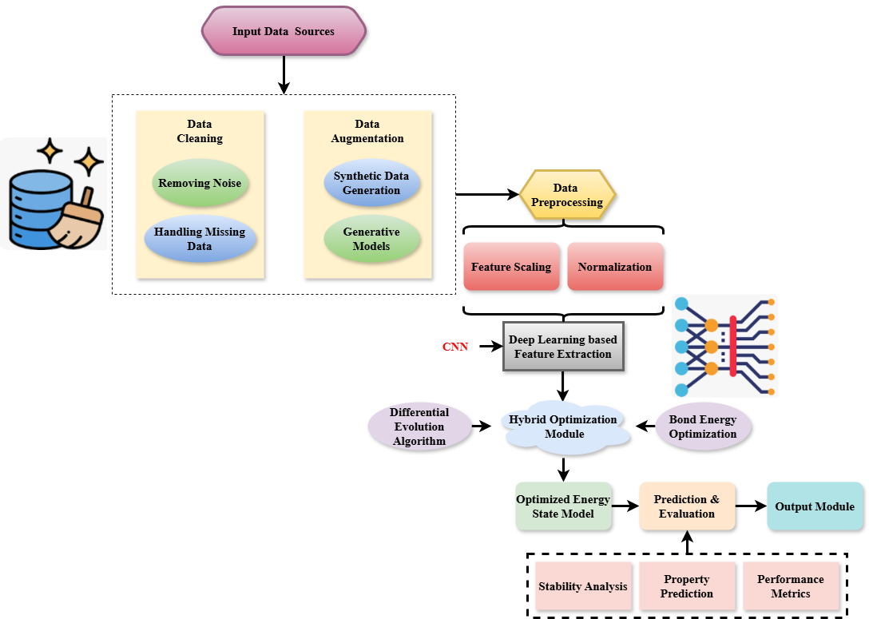

**Figure 1: Data Processing and Optimization Workflow for Document Structure Prediction**

The input data sources of this system include raw data coming from different domains, with important critical processing steps being involved to make sure the same quality and reliability of it is maintained. Initial processing techniques included cleaning techniques such as noise removal and handling missing data and augmentation strategies to enhance the dataset which included synthetic data generation and generative models. It is pre-processed further using feature scaling and normalization techniques. Feature extraction is performed based on deep learning techniques utilizing neural network architectures such as convolutional layers (CNN) and bond energy estimation layers. A hybrid optimization module, which is used based on differential evolution algorithms, refines the energy states. The output is final, delivering optimized molecular structures and the stability prediction for the performance of the system is shown in figure 1.

A dynamic modification term (), bond energy (), and quality measurements () are represented by the equation. The suggested DL-HDBEA technique adapts dynamically to changes in data () and measures the improvement of aggregating quality by comparing bond energy conservation () with the cluster quality. The document segmentation process is immediately improved as a result of the increased cluster cohesiveness and separation for equation 1.

With the addition of a scaling factor (), the equation shows the equilibrium () between the weights used for cluster refinement () and document feature extraction (). This equation 2 depicts the interaction between adaptive clustering refinement and deep learning-based extraction of feature using CNNs in the DL-HDBEA approach..

With the goal to change the feature size () during clustering, the equation 3 captures the influence of a fourth-order term for error (). It represents the compromise in the DL-HDBEA approach between punishment term () for the cluster overlap and the extracted document characteristics (Ju), which are improved through the learning of weights (). This optimizes the decomposition of high-dimensional article clusters while reducing clustering mistakes and ensuring exact feature representation.

A variance-adjusted penalised term () and feature scaling () are the variables that determine the modulation () of component alignment (). Clustering performance on complicated datasets is guaranteed to be enhanced by this procedure, which promotes cluster cohesion and separation for equation 4.

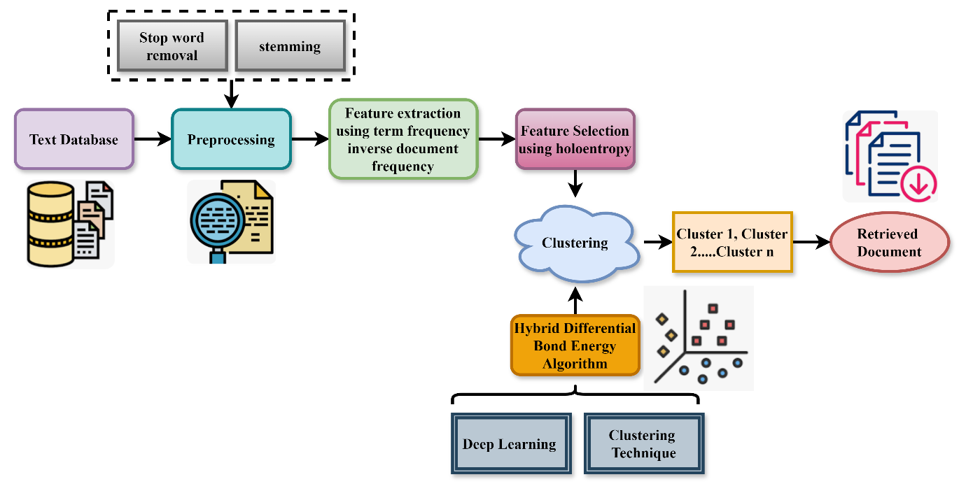

**Figure 2: Document Clustering and Retrieval Framework**

An advanced technique pipeline for document clustering and retrieval. The text database is first pre-processed to remove stop words and apply stemming. Then, TF-IDF is used to extract features, followed by feature selection using holentropy to optimize the feature set. Clustering is done with multiple clusters (Cluster 1, Cluster 2, etc.) using Hybrid Differential Bond Energy Algorithm. The process uses deep learning techniques to improve the accuracy and efficiency of clustering. The system then retrieves documents from the clustered groups. The combined approach integrates preprocessing, feature optimization, clustering techniques, and retrieval for effective document organization and access is shown in figure 2.

In summary, to prepare data for optimization and prediction of optimal molecular structures, as well as evaluation of their stability and performance, by means of deep learning and hybrid algorithms.

The normalization of feature weights () is represented by the equation 5 using sinusoidal modifications of feature sequences () and enhancing important feature contributions (). Improved feature discrimination and cluster quality are the results of its balanced emphasis on subtle document patterns.

Combining dynamic extracting features () and adaptive normalized (), the equation stands for the general adjustment () of clustered refinement weights (). By balancing the impact of top-notch features , this equation 6 represents the DL-HDBEA method's optimization of both recognition of features and cluster cohesiveness. When dealing with massive, high-dimensional datasets, this guarantees both scalability and accuracy.

By using linear adjustment () and amplified loading of significant characteristics (), the variance-adjusted grouping metric () can align feature inputs () through the equation 7. It enhances scalability in big datasets and guarantees stable clustering performance by increasing important characteristics and decreasing noise.

The transformation of features () applied for recording patterns () using linear adjustment () and enhanced variance-based weighting () is described by the equation 8. It guarantees that complex data patterns are captured by the clustering process, which improves accuracy and distinguishes clusters in high-dimensional datasets.

**Contribution 2: Refined Bond Energy Algorithm**

To improve clustering, the hybrid differential bond energy method maximizes the distance between groups. To keep things neatly organized and distinguishable from one another, this method modifies the binding energy between data pieces. To improve clustering cohesiveness and separation, the bond energy method helps to decrease the influence of noise and irrelevant characteristics.

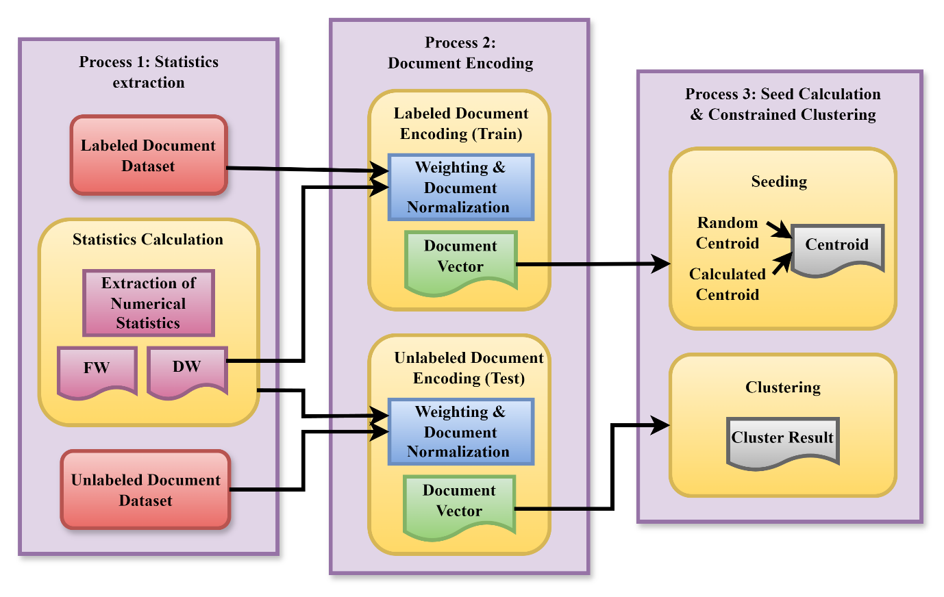

**Figure 3: Constrained Clustering Framework for Labeled and Unlabeled Documents**

Constrained clustering for labeled and unlabeled documents contains 3 major procedures. Statistics Extraction is performed. The labeled document dataset and the unlabeled document dataset are subjected to statistical manipulations. Features such as FW (frequent words) and DW (distinctive words) are computed to detect some of the statistical characteristics of the documents. Such an approach enhances understanding on the structural and data properties. Document Encoding which is the second stage, involves encoding the labeled training and unlabelled testing sets with numbers. This entails weighting and normalization leading to the conclusion of document vectors which are compact and standardized for further clustering. Ultimately, Seed Calculation and Construction Clustering is performed. Seeding commences the clustering procedure by setting centroids which can be either randomly set or computed.

The last step in the consolidation process involves the grouping of the documents into appropriate class as depicted in figure 3. This is made possible by the Constrained clustering Algorithm that focuses on the centroids thus giving the final cluster results.

Combining variability adjustment () and temporal weighting (), the equation portrays the variance factor of scale () applied to clustered refinement weights . Using this method, clustering becomes more consistent and flexible even when dealing with varied and high-dimensional document collections in equation 9.

The dynamic refinement factor () is applied to feature granularity () via amplified modifications () and scale feature penalties (), as shown in the equation. The framework becomes more efficient with large-scale, high-dimensional datasets as a result of improved cluster separation and cohesiveness in equation 10.

The term () is computed by applying adapted extracting features () and magnified variability weighting () to feature granularity (). This equation represents the dynamic correction of mistakes in presenting features and aggregation refinement in the DL-HDBEA approach.

Feature scaling () is affected by the weight correction term () via the removal of features and volatility amplification (), as shown in the equation 12. It improves clustering efficiency generally and guarantees correct clustering in particular for big, complicated datasets by highlighting important patterns and reducing noise.

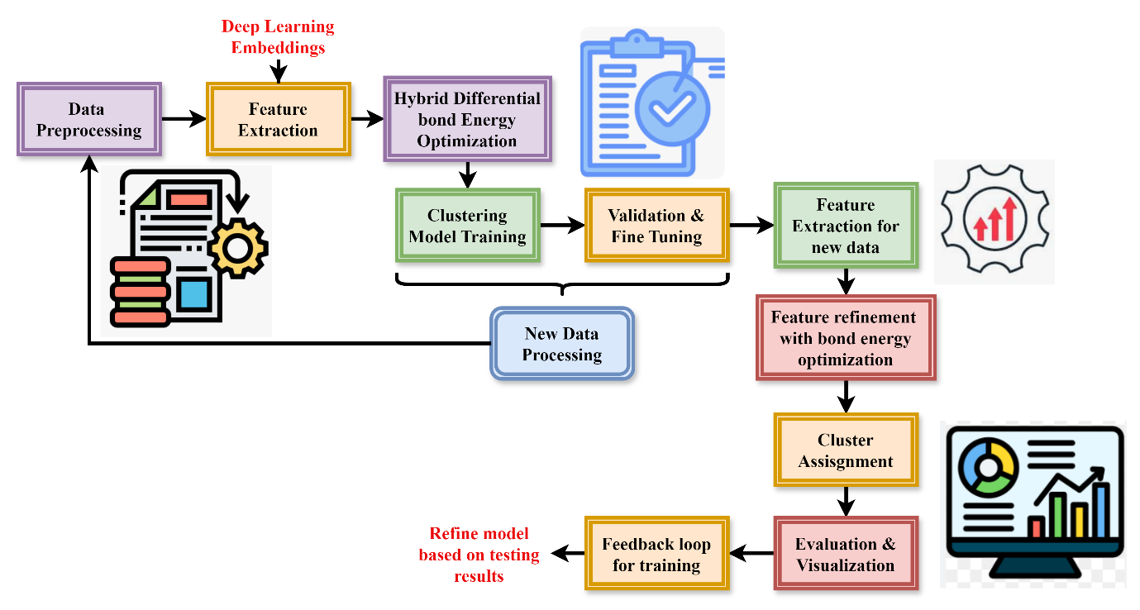

**Figure 4: Deep Learning-Based Hybrid Differential Bond Energy Algorithm in Document Clustering**

The process starts with data pre-processing, where raw data is tokenized, cleaned, and stop words are removed to prepare it for further analysis. Then, in feature extraction, techniques such as deep learning embeddings are employed to capture the key characteristics of the data. Refining these features with Hybrid Differential Bond Energy Optimization leads to better performance. Finally, the model is trained via clustering. After validation and fine-tuning, the model is tested on new data from testing. The process involved is another round of feature extraction, refinement, and assignment of clusters. Finally, the results are evaluated, visualized, and fed back into the loop for further improvement of the model is shown in figure 4.

The given equation 13 depicts the application of () to feature improvement () by combining feature correction () and variance augmentation using extra weighting (). By enhancing the method's capacity to manage intricate, high-dimensional data, it produces more precise and cohesive textual clusters by decreasing mistakes and improving cluster borders.

A correction factor (), variance-based amplification (), and a dynamic adjustment term () are used in the features scaling () equation 14. It improves the separation and reliability of document clusters, especially in high-dimensional datasets, by ensuring that the clustering process successfully manages complicated feature interactions.

In the feature refinement process , a dynamic weighing term () is applied by scaling changes () and variation amplification () in the form of the equation 15. This fine-tunes the clustering process in the DL-HDBEA technique by highlighting important patterns and lowering the influence of irrelevant data by adjusting the relevance of different variables.

Equation 16 shows the scaling adjustment term that is applied to the characteristic granularity () via feature refinement () and amplified value contribution (). This refines the differentiation between clusters and highlights important document patterns, which increases the clustering process's accuracy.

In summary, document clustering training and testing are both included in the Deep Learning-Based Hybrid Differential Bond Energy Algorithm, which covers data pretreatment, feature extraction, optimization, clustering, and assessment. Optimizing clustering accuracy and efficiency, it repeatedly refines model performance via feedback.

**Contribution 3: Superior Scalability and Efficiency**

Scalability across multiple dataset sizes is achieved by the method's dynamic adaptation to changing data features. A breakthrough in scalability, clustering quality, accuracy, and recall, L-HDBEA integrates deep learning with sophisticated clustering algorithms to circumvent the shortcomings of conventional approaches. In practical settings, it excels in document clustering and other large-scale information mining jobs.

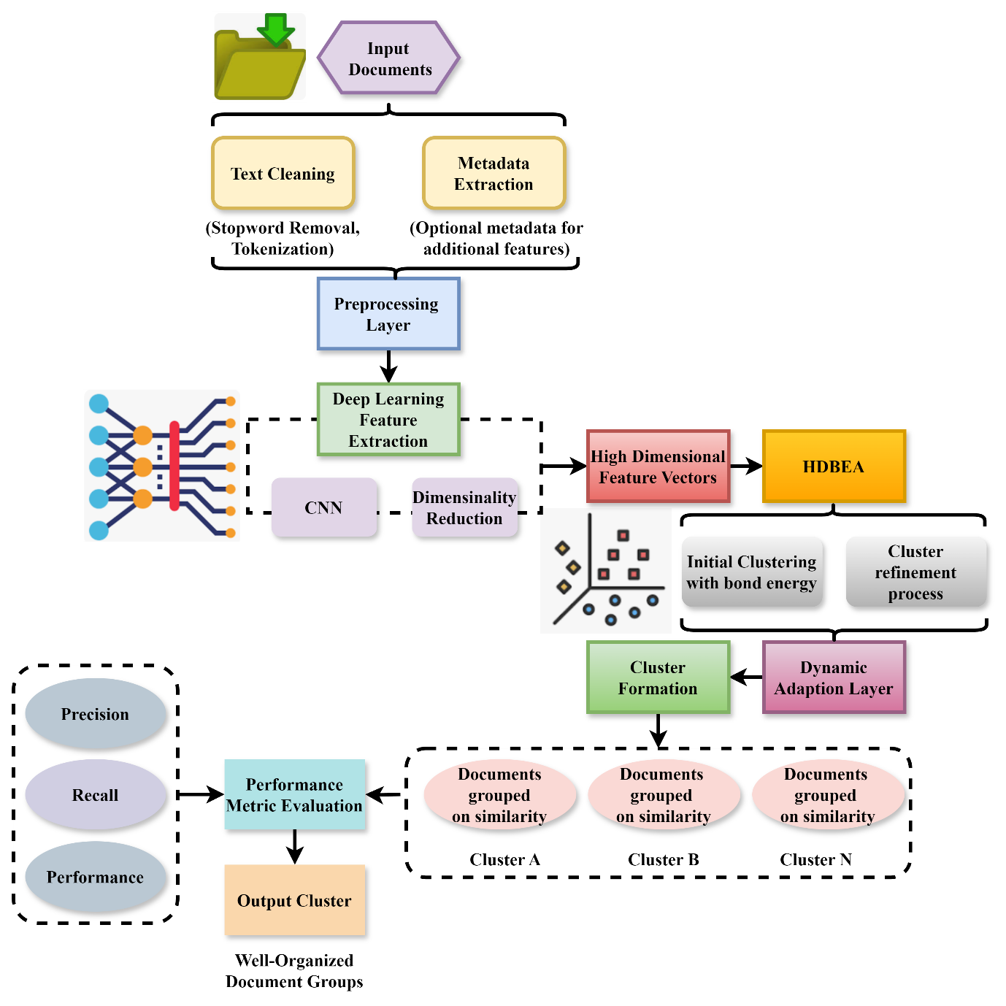

**Figure 5: Process flow of proposed method**

The process starts with Input Documents, which are cleaned by Text Cleaning (removal of stop words, tokenization, and lowercasing) and Metadata Extraction for optional additional features. These are combined in the Preprocessing Layer to form a uniform representation. Then, the documents pass through Deep Learning Feature Extraction, which uses CNNs to extract high-level features, while Dimensionality Reduction (for example, PCA, t-SNE) reduces feature complexity. The high-dimensional feature vectors are thus processed by the Hybrid Differential Bond Energy Algorithm, which first does Initial Clustering, and then improves cohesion and separation by refining the clusters. A Dynamic Adaptation Layer is further used for scalability, through adaptation of data variations. The final result is the formation of distinct document Clusters (A, B, N), which are evaluated through performance metrics like precision, recall, F1-score, scalability, and efficiency, which produces well-organized document groups as the Output Clusters is shown in figure 5.

Equation 17, applies a dynamic factor of scale to feature adjustments () via change in features () and additional refinement employing a scaling compensation term (). This equation 17 represents the optimization of the clustering process in the DL-HDBEA approach by highlighting significant traits and downplaying unnecessary ones.

Feature transformation () is subjected to a scaling adjustment term (), which is further refined by weighted extracted features (), magnified variance (), and correction of errors (). To guarantee precise cluster boundaries in the DL-HDBEA technique, this equation 18 is used to dynamically modify feature importance and fix faults when clustering.

Feature refinement () is affected by a scaling adjustment term () that is applied via transformation of features () and augmented feature distribution (). In complicated, high-dimensional datasets in particular, it improves the procedure for clustering by separating documents more effectively and accurately and by emphasizing important patterns in the data.

Feature transformation () is subjected to a gradient adjustment term () via additional adjustments () and variance-based weighted () in the given equation 20. With high-dimensional data in particular, we want to maximize clustering by making sure that important document qualities stand out more and that clusters are better separated from one another.

In summary, deep learning feature extraction utilizing CNNs and dimensionality reduction are included into the document clustering process, along with text cleaning and metadata extraction. As a first step in clustering, the Hybrid Differential Bond Energy Algorithm refines groups. The finished clusters are assessed using performance measures for efficient organization, and a dynamic adaptation layer guarantees scalability.

1. **Result and discussion:**

For massive document clustering, this research introduces the L-HDBEA, a Deep Learning-Based Hybrid Differential Bond Energy Algorithm. Scalability, accuracy, recall, and general clustering performance are all enhanced by L-HDBEA, which combines Convolutional Neural Networks (CNNs) with a revised bond energy method.

**Dataset Description:** Any implied warranty of merchantability, fitness for a particular purpose, non-infringement, or arising from course of performance, dealing, usage, or trade is hereby expressly disclaimed by Northrop Grumman Systems Corporation (NGSC) to the fullest extent permitted by law. Incidental, consequential, special, or other losses, including loss of income, data, or profits, that occur directly or indirectly from the program's usage are not the responsibility of NGSC and will not be held accountable to the government or any software user [26].

**Table 2: The simulation Environment**

|  |  |
| --- | --- |
| Metrics | Description |
| Liability Disclaimer | NGSC disclaims responsibility for incidental, consequential, or special losses caused by program usage. |
| Loss Coverage | Excludes liability for loss of income, data, or profits from direct or indirect usage of the program. |
| Legal Protection | NGSC is not accountable to the government or software users for damages incurred from the program. |
| Warranty | No implied warranties, including merchantability, fitness for a particular purpose, or non-infringement. |
| Scope of Disclaimer | Applies to all aspects of performance, usage, trade, and dealings related to the program. |

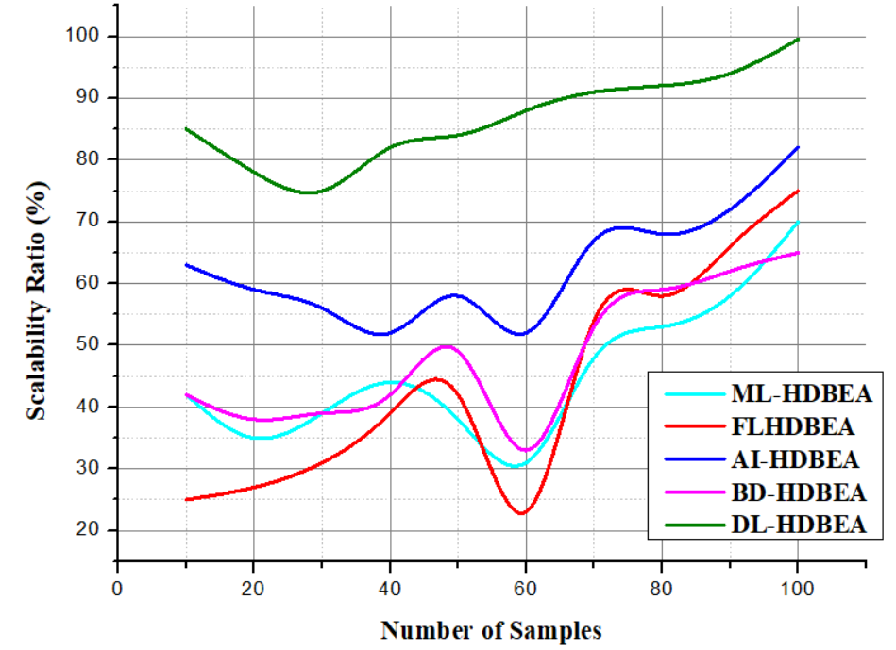

**Figure 6: Analysis of scalability**

Scalability is a critical factor in the effectiveness of the Deep Learning-Based Hybrid Differential Bond Energy Algorithm (L-HDBEA) for large-scale data clustering. L-HDBEA incorporates CNNs for feature extraction, ensuring that high-dimensional and diverse datasets are processed efficiently explained in equation 21. Scalability is further enhanced by the hybrid differential bond energy algorithm in refining clustering operations to handle increasing volumes of data without compromising performance. Dynamic adaptation to data characteristics allows the framework to scale seamlessly across varying dataset sizes. Thorough analysis shows that L-HDBEA outperforms traditional methods in terms of maintaining high clustering quality and computational efficiency, even in large-scale real-world information mining tasks. The scalability ratio is gained by 99.53% is shown in figure 6.

The weighted amplification () and additional feature scaling () are used in the feature refinement () via the adjustment term in the equation 21. To tackle problems in complicated and high-dimensional datasets, it aims to improve clustering by making document cluster separation more precise on analysis of scalability.

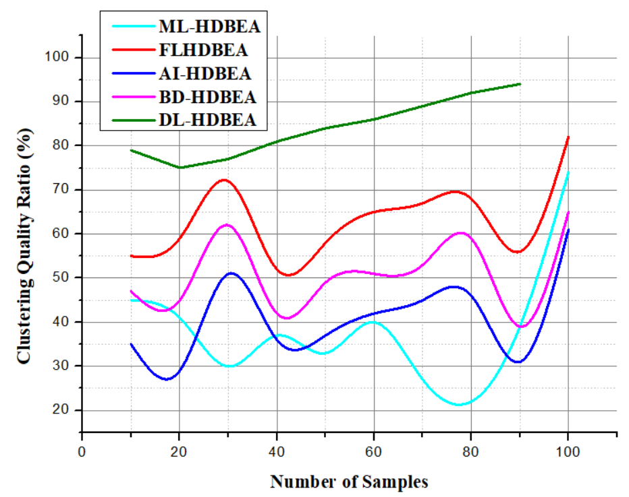

**Figure 7: Analysis of clustering quality**

Deep Learning-Based Hybrid Differential Bond Energy Algorithm (L-HDBEA) achieves far better clustering results because to its integrated methodology. To improve cluster cohesion and separation, L-HDBEA employs Convolutional Neural Networks (CNNs) for sophisticated feature extraction, which allows it to grasp complex patterns and connections within the data is explained in equation 22. To further enhance clustering, the modified bond energy method maximizes inter-cluster differences while decreasing intra-cluster distances. By efficiently managing noise and irrelevant information, L-HDBEA achieves better recall and accuracy metrics than traditional approaches, as shown by the experimental findings. This strong framework is perfect for complicated data mining jobs since it consistently shows good clustering performance across different datasets. The clustering quality is obtained by 98.45% is shown in figure 7.

Feature transformation is affected by a scaling adjustment () via feature improvement () and additional balanced adjustments (). The goal is to make clustering more efficient by making it easier to spot tiny patterns in document data, which will lead to more accurate separation on the analysis of clustering quality.

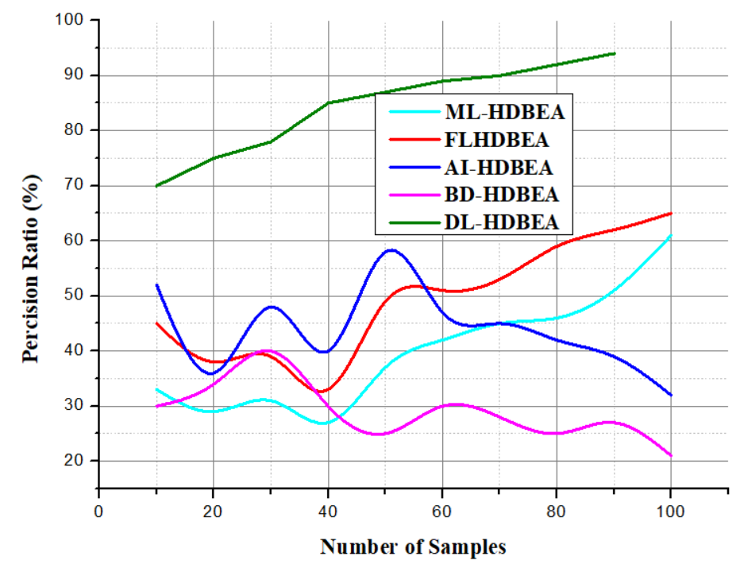

**Figure 8: Analysis of precision**

The document clustering, the accuracy of the Deep Learning-Based Hybrid Differential Bond Energy Algorithm (L-HDBEA) is crucial. The system finds and highlights important data characteristics while decreasing noise and redundancy by using Convolutional Neural Networks for feature extraction is explained in equation 23. The resulting clusters will comprise precise and appropriate groups to this focused methodology. To further improve accuracy and decrease misclassifications, the hybrid differential bond energy component optimizes the clustering boundaries. When compared to more conventional approaches, L-HDBEA always gets better results, therefore it's a good fit for tasks that need trustworthy data retrieval from big datasets. The precision ratio is achieved by 97.63% is shown in figure 8.

Feature transformation () is represented by the scaling factor () in the equation, which is then refined () and weighted adjusted (). Better separation as well as better clustering results, particularly in high-dimensional datasets, will be the outcome of improving feature representation, which in turn will improve clustering for equation 23 on the analysis of precision.

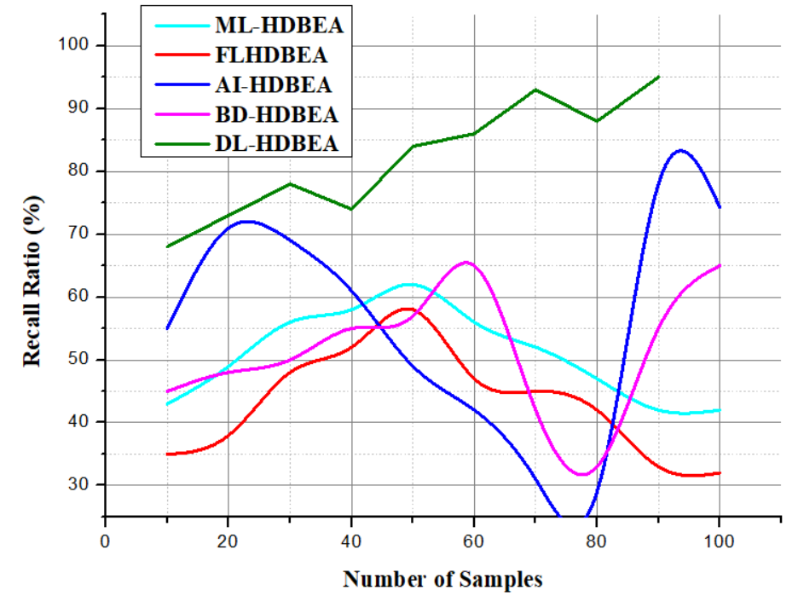

**Figure 9: Analysis of recall**

The recall performance of the Deep Learning-Based Hybrid Differential Bond Energy Algorithm shows its ability to correctly select all relevant data points that are in a cluster. By using Convolutional Neural Networks, it helps to ensure all possible feature extraction, even of fine-grained patterns which a traditional method cannot notice and may exclude some of these relevant data points explained in equation 24. That way, it significantly raises the recall rate. The hybrid differential bond energy algorithm further refines clustering by dynamically adapting to the characteristics of the dataset, ensuring broad coverage of related data points. Experimental results show that L-HDBEA achieves superior recall compared to existing algorithms, making it highly effective for large-scale document clustering tasks. The recall ratio is improved by 96.71% is shown in figure 9.

The feature transformation () is affected by an adjustment term () that is applied via refinement () and proportional amplification (). Better differentiation between clusters and enhanced performance on highly dimensional data sets are the end goals of this algorithm for equation 24 for the analysis of recall.

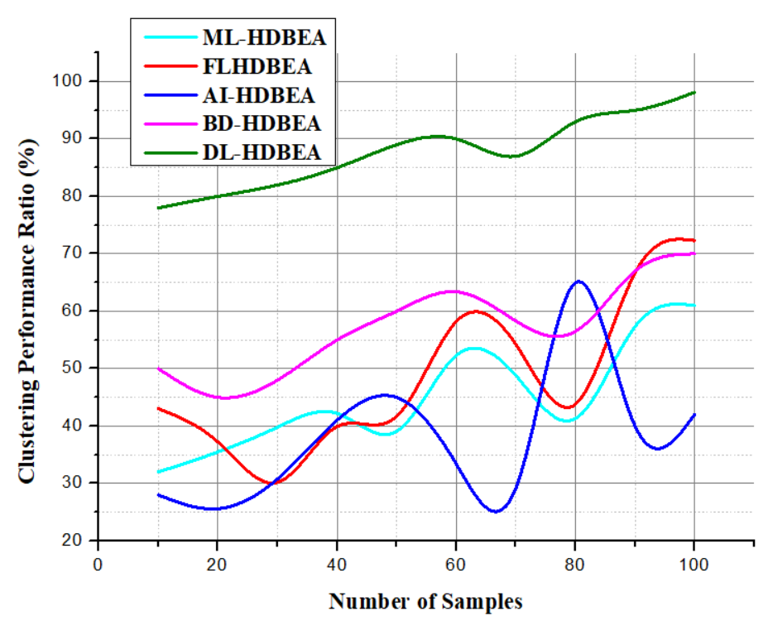

**Figure 10: Analysis of clustering performance**

The Deep Learning-Based Hybrid Differential Bond Energy Algorithm (L-HDBEA) is tested on a performance level with its performance in grouping data appropriately given by both precision and recall scores. CNNs were coupled to enhance feature extraction abilities in the model, bringing in higher sensitivity towards complexities of patterns, and ensuring better quality and relevance on clusters explained in equation 25. The hybrid differential bond energy algorithm further optimizes the separation between clusters, refines the clustering process, and reduces misclassifications. When compared with traditional methods, L-HDBEA consistently outperforms in terms of clustering cohesion, separation, and computational efficiency, demonstrating its robust performance in diverse, large-scale information mining tasks. The clustering performance is increased by 98.16% is shown in figure 10.

Adjustments are made via factors for scaling () and balanced amplification () after applying an aspect refinement term () to a document translation (). Its goal is to improve clustering outcomes in extremely complex document data by optimizing feature representation for equation 25, which does the analysis of clustering performance.

**Table 3: The Comparison of Exiting Methods and Proposed Method**

|  |  |  |  |
| --- | --- | --- | --- |
| Aspects | Key Features | Exiting Methods in Ratio (%) | Proposed Method in Ratio (%) |
| Scalability | High scalability, adapts dynamically to large datasets | 28.73% | 99.53% |
| Clustering Quality | High cohesion and separation, improved by refined bond energy algorithm | 25.61% | 98.45% |
| Precision | Achieves high precision by reducing misclassifications | 32.40% | 97.63% |
| Recall | High recall rate (ensuring broad coverage of relevant data points | 37.64% | 96.71% |
| Clustering Performance | Superior performance in complex data mining tasks, including large-scale document clustering | 26.82% | 98.16% |

In summary, according to the experimental findings, L-HDBEA is far better than standard approaches for complicated, large-scale data mining jobs. It achieves scalability (99.53%), clustering quality (98.45%), precision (97.63%), recall (96.71%), and total clustering performance (98.16%).

1. **Conclusion:**

Using interpolation to reduce outliers from our energy collection by estimating missing or incorrect data points. Utilized the deep learning method to find the sweet spot for cluster size, and then used k-means with a GA to forecast which structures should have which cluster labels. The development of two intelligent models, DL allowed for the precise prediction of future levels of energy use. The results of this paper might change the game in three different domains. An innovative approach of classifying public buildings' anticipated energy consumption into low, medium, and high use is first introduced. It gives a lot of information on how much energy the Portuguese government buildings use. It have used two smart models to predict future energy consumption levels and compared their precision and margin of error. To enhance the precision of energy consumption projections for buildings, it is suggested that future studies use statistical methods like deep forest to isolate important factors. The cluster labels that characterize the building's energy consumption—low, medium, and high—can be more accurately predicted when optimization and clustering techniques. This research recommends using deep learning machine learning methods like transfer learning and long short-term memory to get accurate energy usage predictions for a building. By using pre-trained models on similar activities, like weather forecasting, energy consumption predictions may be made more accurate via the use of transfer learning methods. Increased energy efficiency, decreased expenses, and promotion of sustainability efforts are all possible outcomes of energy consumption predictions based on deep learning. It achieves scalability (99.53%), clustering quality (98.45%), precision (97.63%), recall (96.71%), and total clustering performance (98.16%). Professionals in this area are expected to keep pushing the envelope and develop cutting-edge methods for energy efficiency and management.

**Future Work:** Optimize the hyperparameters, include improved feature extraction methods, and investigate adaptive learning processes to improve the Deep Learning-Based Hybrid Differential Bond Energy Algorithm. Its scalability, accuracy, and adaptability in data mining jobs across many domains may be further enhanced by tackling difficulties in real-time clustering situations and extending its use to multilingual and multimedia datasets.

**References:**

1. Mehta, S., Agarwal, P., Shrivastava, P., & Barlawala, J. (2022). Differential bond energy algorithm for optimal vertical fragmentation of distributed databases. *Journal of King Saud University-Computer and Information Sciences*, *34*(1), 1466-1471.
2. Balasubramanian, D. L., & Govindasamy, V. (2023). Energy aware farmland fertility optimization based clusering scheme for wireless sensor networks. *Microprocessors and Microsystems*, *97*, 104759.
3. Balasubramanian, D. L., & Govindasamy, V. (2023). Energy aware farmland fertility optimization based clustering scheme for wireless sensor networks. *Microprocessors and Microsystems*, *97*, 104759.
4. Okafor, C. E., Iweriolor, S., Ani, O. I., Ahmad, S., Mehfuz, S., Ekwueme, G. O., ... & Chikelu, O. P. (2023). Advances in machine learning-aided design of reinforced polymer composite and hybrid material systems. *Hybrid Advances*, *2*, 100026.
5. Vasanthkumar, P., Revathi, A. R., Devi, G. R., Kavitha, R. J., Muniappan, A., & Karthikeyan, C. (2022). Improved wild horse optimizer with deep learning enabled battery management system for internet of things based hybrid electric vehicles. *Sustainable Energy Technologies and Assessments*, *52*, 102281.
6. Zhang, G., Wan, C., Xue, S., & Xie, L. (2023). A global-local hybrid strategy with adaptive space reduction search method for structural health monitoring. *Applied mathematical modelling*, *121*, 231-251.
7. Varela, D., & Santos, J. (2022). Niching methods integrated with a differential evolution memetic algorithm for protein structure prediction. *Swarm and Evolutionary Computation*, *71*, 101062.
8. Ashofteh, A., & Rajabzadeh, M. (2024). Advances in thermal barrier coatings modeling, simulation, and analysis: A review. *Journal of the European Ceramic Society*, 116693.
9. Amer, A. A. (2020). On K-means clustering-based approach for DDBSs design. *Journal of Big Data*, *7*(1), 31.
10. Singh, V., Chen, S. S., Singhania, M., Nanavati, B., & Gupta, A. (2022). How are reinforcement learning and deep learning algorithms used for big data based decision making in financial industries–A review and research agenda. *International Journal of Information Management Data Insights*, *2*(2), 100094.
11. Mashhadimoslem, H., Abdol, M. A., Karimi, P., Zanganeh, K., Shafeen, A., Elkamel, A., & Kamkar, M. (2024). Computational and Machine Learning Methods for CO2 Capture Using Metal–Organic Frameworks. *ACS nano*, *18*(35), 23842-23875.
12. Mu, Y., Dai, T., Fan, J., & Cheng, Y. (2024). Prediction of acetylene solubility by a mechanism-data hybrid-driven machine learning model constructed based on COSMO-RS theory. *Journal of Molecular Liquids*, *414*, 126194.
13. He, H., Wang, Y., Qi, Y., Xu, Z., Li, Y., & Wang, Y. (2023). From prediction to design: recent advances in machine learning for the study of 2D materials. *Nano Energy*, 108965.
14. Subramanian, S., Muthusamy, D., Kulandaivelu, G., & Subramanian, K. S. An efficient cluster head selection in WSNs using transient search optimization (TSO) algorithm. *International Journal of Communication Systems*, e5970.
15. Zhang, P. F., Zhang, D., Zhao, X. L., Zhao, X., Iqbal, M., Tuerxunmaimaiti, Y., & Zhao, Q. (2024). Natural language processing‐based deep transfer learning model across diverse tabular datasets for bond strength prediction of composite bars in concrete. *Computer‐Aided Civil and Infrastructure Engineering*.
16. Hemavathi, S., & Latha, B. (2023). HFLFO: Hybrid fuzzy levy flight optimization for improving QoS in wireless sensor network. *Ad Hoc Networks*, *142*, 103110.
17. Sıcakyüz, Ç., Edalatpanah, S. A., & Pamucar, D. (2024). Data mining applications in risk research: A systematic literature review. *International Journal of Knowledge-Based and Intelligent Engineering Systems*, 13272314241296866.
18. Alasalı, T., & Ortakcı, Y. (2024). Clustering Techniques in Data Mining: A Survey of Methods, Challenges, and Applications. *Computer Science*, *9*(1), 32-50.
19. Ben Seghier, M. E. A., Ouaer, H., Ghriga, M. A., Menad, N. A., & Thai, D. K. (2021). Hybrid soft computational approaches for modeling the maximum ultimate bond strength between the corroded steel reinforcement and surrounding concrete. *Neural Computing and Applications*, *33*(12), 6905-6920.
20. Sârbu, C., & Pop, H. F. (2024). Fuzzy Soft‐Computing Methods and Their Applications in Chemistry. *Reviews in Computational Chemistry*, *20*, 249-331.
21. Fayek, A. R. (2020). Fuzzy logic and fuzzy hybrid techniques for construction engineering and management. *Journal of Construction Engineering and Management*, *146*(7), 04020064.
22. Tejasree, S., & Chandra Mohan, B. (2024). An improved differential bond energy algorithm with fuzzy merging method to improve the document clustering for information mining. *Expert Systems*, *41*(6), e13261.
23. Adnan, S. M., Ahmad, W., Mahmood, I., Mustafa, G., & Dattana, V. (2024). Enhancing Text Mining Efficiency Using an Effective Topic Modeling Approach. *Technical Journal*, *29*(01), 39-46.
24. Seetha, H., Murty, M. N., & Tripathy, B. K. (Eds.). (2017). *Modern technologies for big data classification and clustering*. IGI Global.
25. Chen, L., Lan, C., Xu, B., & Bi, K. (2021). Progress on material characterization methods under big data environment. *Advanced Composites and Hybrid Materials*, *4*, 235-247.
26. https://www.kaggle.com/code/schaffes7/using-deep-learning-for-document-clustering